Experiment no:1
Experiment name: Port scanning tools
Aim: To study and perform different types of port scanning using Nmap in Kali Linux.
Procedure:
- Open Kali Linux and launch Nmap from Applications → Information Gathering.
- Open the terminal and perform port scanning on an authorized target system.
- Use -sS to perform a TCP SYN scan.
- Use -sT to perform a TCP Connect scan.
- Use -sU to perform a UDP scan.
- Use -sA to perform a TCP ACK scan.
- Observe and record the open, closed, and filtered ports displayed by Nmap.
Screenshots:
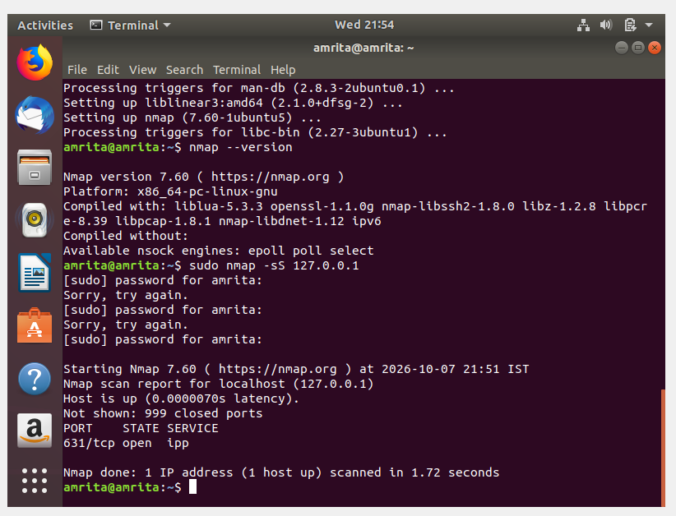
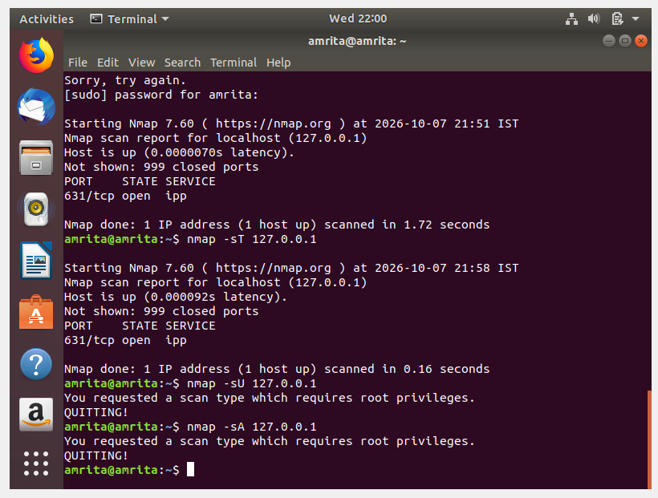

Result:
Thus, different types of port scanning were studied and performed using Nmap, and the port status of the target system was observed.

